**Motion Capture Interpolation Report**

Class Name: Computer Animation and Simulation

Name: Haohan Wang

USC ID: [haohanwa@usc.edu](mailto:haohanwa@usc.edu)

# Part 1:

**Constraint 1**:

* for lfemur joint, rotation around Y axis, frames 600-800,
* for N=20, for 131_04-dance.amc input file

Graph #1:

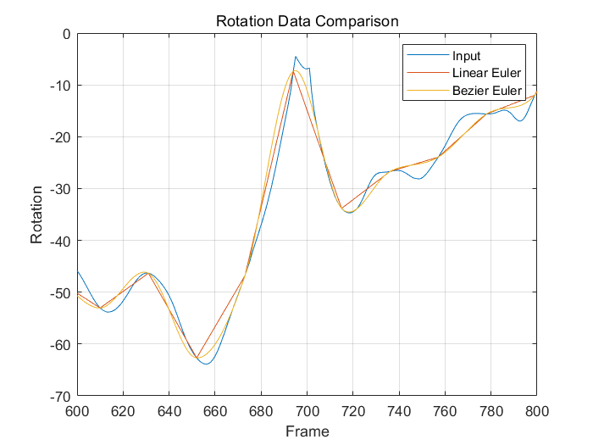

Graph #2:

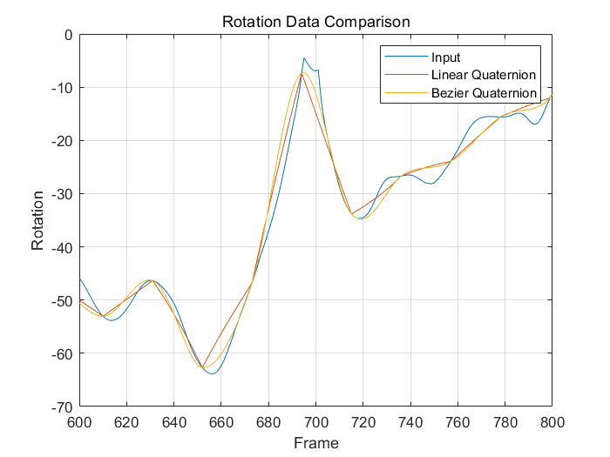

**Conclusion 1:**

Based on the diagrams presented, the Bezier methods demonstrates superior smoothness in handling interpolation compared to the Linear methods. Especially where input frames exhibit up-and-down fluctuations, with limited keyframes, Bezier interpolation closely simulates the original motion.

# Part 2:

**Constraint 2:**

* for root joint, rotation around Z axis, frames 200-500,
* for N=20, for 131_04-dance.amc input file.

Graph #3:

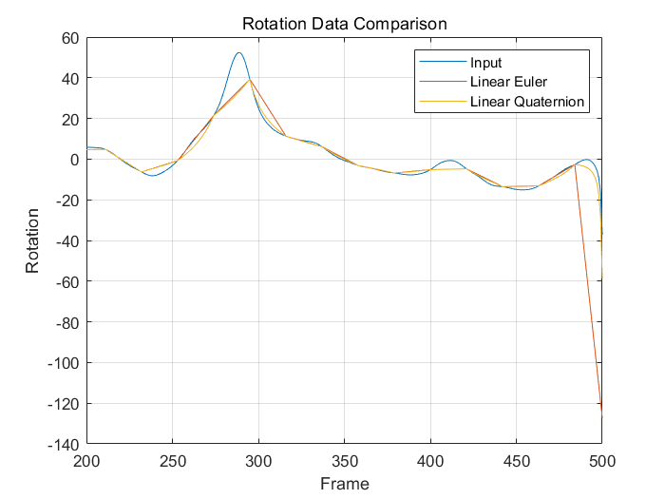

Graph #4:

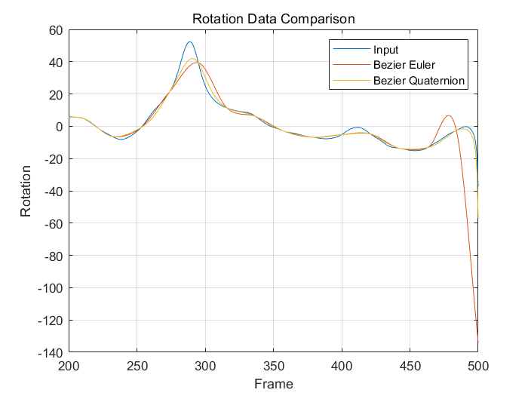

**Conclusion 2:**

Based on the diagrams presented above, Quaternion methods exhibit a higher degree of interpolation accuracy compared to Euler methods in executing interpolations. This is particularly noticeable at the peaks and valleys of the motion data, where the resulting positions derived from Euler methods show a greater deviation than Quaternion methods.

# Part 3:

**Runtime records:**

**(extra credits)**

**Record 1:**

/* Input file: 131_04-dance.amc*/

*(from Frame 1 to 1086)*

Interpolation type is: LINEAR

Angle representation for interpolation is: EULER

Interpolating...

Linear Interpolation Euler time: 0.111401

Interpolation type is: LINEAR

Angle representation for interpolation is: QUATERNION

Interpolating...

Linear Interpolation Quaternion time: 0.529284

Interpolation type is: BEZIER

Angle representation for interpolation is: EULER

Interpolating...

Bezier Interpolation Euler time: 0.689141

Interpolation type is: BEZIER

Angle representation for interpolation is: QUATERNION

Interpolating...

Bezier Interpolation Quaternion time: 1.605521

**Record 2:**

/* Input file: 135_06-martialArts.amc*/

*(from Frame 1 to 3261)*

Interpolation type is: LINEAR

Angle representation for interpolation is: EULER

Interpolating...

Linear Interpolation Euler time: 0.264375

Interpolation type is: LINEAR

Angle representation for interpolation is: QUATERNION

Interpolating...

Linear Interpolation Quaternion time: 1.305950

Interpolation type is: BEZIER

Angle representation for interpolation is: EULER

Interpolating...

Bezier Interpolation Euler time: 1.717621

Interpolation type is: BEZIER

Angle representation for interpolation is: QUATERNION

Interpolating...

Bezier Interpolation Quaternion time: 4.153139

**Conclusion 3:**

While Bezier and Quaternion interpolation methods yield superior results in terms of accuracy and smoothness, it's important to note their considerably longer runtime compared to linear and Euler methods. This is further compounded when both methods are used concurrently. Therefore, computational efficiency becomes a critical factor, particularly in real-time applications where processing speed is essential.

# Part 4:

**Conclusion**

Based on the analysis above, my conclusions are as follows: for smoother interpolation, the Bezier method is preferable; for higher accuracy, the Quaternion method stands out as the method of choice; and for applications requiring real-time performance, a choice between Euler and Linear methods might be more appropriate, depending on specific requirements and constraints.